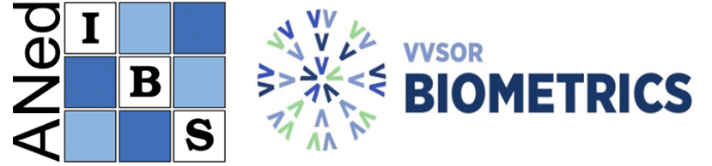

Annual report 2024-2025 of BMS and ANed

Board COMPOSITION

Composition BMS board before BMS-ANed General Assembly 19 June 2025:
Marianne Jonker – Radboud UMC (President)
Mar Rodríguez-Girondo - LUMC (Secretary)
Dennis te Beest - WUR (Treasurer)
Roula Tsonaka - LUMC (PR officer)
Joost van Rosmalen - Utrecht UMC (Member)
Jeroen Hoogland - Amsterdam UMC (Member, webmaster)
Floor van Oudenhoven - DANONE (Member)
Wouter van Amsterdam – Utrecht UMC (Member)
Sara Baart – Erasmus MC (Member)

Composition BMS board after BMS-ANed General Assembly 19 June 2025:
Marianne Jonker – Radboud UMC (President)
Mar Rodríguez-Girondo - LUMC (Secretary)
Dennis te Beest - WUR (Treasurer)
Sara Baart – Erasmus MC (PR officer)
Joost van Rosmalen – Utrecht UMC (Member)
Jeroen Hoogland – Amsterdam UMC (Member, webmaster)
Floor van Oudenhoven – DANONE (Member)
Wouter van Amsterdam – Utrecht UMC (Member)

Activities
1. HANS VAN HOUWELINGEN AWARD 2025 CEREMONY AND SYMPOSIUM
Date: Thursday, 19 June 2025
Location: Vredenburg, 19, Utrecht

SPEAKERS
Tomasz Burzykowski – Hasselt University
Paul Blanche – University of Copenhagen
Jessica Barrett – University of Cambridge
2. TRAINING COURSE: DATA AND SAFETY MONITORING BOARDS

The BMS-ANed organized a course for methodologists interested in serving on Data and Safety Monitoring Boards (DSMBs). It combined expert-led lectures with interactive small group sessions, where participants worked through practical scenarios that reflect the challenges faced by DSMBs, gaining a deeper understanding of key responsibilities such as monitoring interim data, evaluating the safety of participants, and making data-driven decisions on the continuation of the study.

Date: Wednesday, 27 November 2024
Time: 09:30-16:30 (CET)
Location: Vredenburg 19, Utrecht

INSTRUCTORS
Prof. Kit Roes – Radboud UMC
Prof. Saskia le Cessie - LUMC
Dr. Rob Kessels – Utrecht UMC

3. ONLINE SEMINARS
The Biostatistics seminar series started in 2022 and targets a broad (bio)statistical audience, particularly PhD-students. Specialists discuss a topic of their interest, paying particular attention to concepts relevant and accessible to a non-specialist audience as well.

i) 26th September 2024, 16:0017:00 (CET)
Speaker: Wouter van Amsterdam (Utrecht UMC)
Title: “Artificial Intelligence in Health care”

ii) 30th January 2025, 16:00-17:00 (CET)
Speaker: Dimitris Mavridis (University of Ioannina)
Title: “A gentle introduction to network meta-analysis. Current state and future challenges”

iii) 12th June 2025, 16:00-17:00 (CET)
Speaker: Wessel van Wieringen (VUMC, Department of Mathematics VU)
Title: “Regularization: essentials, connections, and applications”

